Predicting Remaining Player WAR

The purpose of this analysis was to predict the remaining wins above replacement (WAR) a player will generate through the age of 30. WAR represents the productivity of a player relative to a “replacement” player at their position, replacement being a top tier AAA or bottom tier MLB player. To further put this in perspective, every one WAR a player generates during the regular season is worth between $4-5 million. Accurately projecting WAR provides the organization with valuable information in determining a players’ worth.
Player age, preseason rank, hitting, and defensive position data provided by the Orioles organization was used in the analysis. Offensive data was used to calculate offensive runs above average (RAA) and defensive data was used to calculate defensive RAA. Offensive and defensive RAA are the two determining factors of WAR. Python, MySQL Workbench, and Excel were used to generate the final data set and to perform the machine learning model.
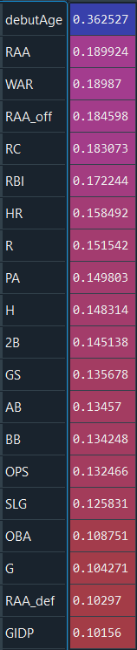
There were 35 total player statistics that were tracked in this process, but to improve model accuracy and reduce model run time, not all of these were used. Only features with a relatively high correlation to the target variable, cumulative WAR through the age of 30, were passed in the model. The top 20 correlating metrics were taken and are shown in the column image displayed right. The age in which a player makes his debut is the highest correlating feature, which makes sense because the years before a player turns 30 is the same amount of time he has to accumulate WAR. Other interesting metrics found to have a relatively high correlation with cumulative WAR were walks (BB), on base plus slugging (OPS), doubles (2B), and runs created (RC).
The data used for the machine learning model was then trimmed down relatively recent years, between 1994 and 2017, and using only the statistics seen on the right. The data set was split into a training set and a test set, 80% train and 20% test. The training set is how the model ‘learns’ the relationship between the input metrics and the target variable. The test set is used to apply the newly determined relationship and make predictions of the target variable. How accurately the model performs on the test set is the model’s score. The scoring method used for this regression model was coefficient of determination (r-squared) and was found to be 0.542. An r² of 0.542 is not great but is not entirely useless if there is a pattern within the instances the model performed well. For example, 20% of the models’ predictions were accurate to within 14% error.

Since the model attempts to take a single years’ performance to predict remaining player WAR, I plotted single season WAR against prediction percent error. Below you can see a clear inverse relationship. As the single season WAR increases, the percent error in the prediction decreases.
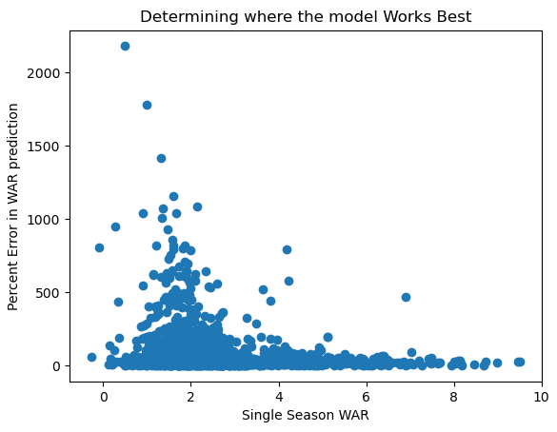
Plotting this exposed some flaws in the data set used for the model that must be improved upon for future iterations. The target variable created to train the model was the cumulated WAR each player had by the age of thirty. Many of the players in the training set did not play until they were thirty, but the model doesn’t know that. The model sees a year of performance and the player’s age and uses it to predict remaining WAR assuming they play through age thirty. The model performed poorly on players that stopped playing before age thirty because it expects them to have more years in the league to accumulate WAR. Another source of error could be in the equations used to calculate WAR from the data set. The equations found in the end of this document are simplified from the conventional ones used by, for example, baseball reference.
Name | Year | Age | WAR calculated | WAR baseball reference | Total WAR (2017-2021) | WAR pred | Error | %Error
Anthony Rendon | 2017 | 27 | 6.2 | 6.1 | 20.5 | 32.7 | -12.2 | -59.4
Mitch Haniger | 2017 | 27 | 3.0 | 3.1 | 14.2 | 15.3 | -1.1 | -7.5
James McCann | 2017 | 27 | 2.6 | 1.4 | 5.4 | 15.9 | -10.5 | -194.4
Brian Goodwin | 2017 | 27 | 2.7 | 0.3 | 1.5 | 11.7 | -10.2 | -683.1
Chris Taylor | 2017 | 27 | 4.1 | 4.4 | 17.8 | 20.2 | -2.4 | -13.6
Nick Ahmed | 2017 | 27 | 2.2 | 0.5 | 8.1 | 14.8 | -6.7 | -83.2
Tyler Collins | 2017 | 27 | 1.3 | -0.1 | -0.1 | 11.8 | -11.9 | 11879.0
Salvador Perez | 2017 | 27 | 3.6 | 2.5 | 12.2 | 29.6 | -17.4 | -142.6
Joe Panik | 2017 | 27 | 3.0 | 1.5 | -1.3 | 17.7 | -19.0 | 1457.7
Jett Bandy | 2017 | 27 | 1.7 | -0.8 | -1.1 | 9.9 | -11.0 | 1003.6
Tim Beckham | 2017 | 27 | 2.1 | 2.5 | 3.3 | 17.2 | -13.9 | -420.1

The above table shows instances in which the model performed poorly. All of the players were 27 in the year 2017, and from the perspective of the model, accumulate WAR for the next four seasons through 2021. The difference between the ‘WAR calculated’ and ‘WAR baseball reference’ displays the discrepancy between the simplified method of calculating WAR in the model and actual WAR. The ‘WAR pred’ column shows the predicted WAR the player will accumulate through the 2021 season, where as the ‘Total WAR’ column shows the WAR the player actually accumulated. It should be noted that the model did not account for the shortened 2020 season, which is part of the reason why the model consistently overestimated in this timespan. Many of these players did not play all years between 2017 and 2021. Collins’ last year was 2017, Bandy’s last year was 2018, Beckham’s was 2019, Perez sat out 2019 due to injury, and Haniger didn’t play all of 2020. Worse performing players get less playing time, even sent down to the minors or cut. The model assumes that the player will play completely through the age of the 30, which is why it favors players with higher WAR like Chris Taylor, as they are more likely to continue to play and succeed.

Equations
RAA_{off} = PA * (OPS – league_avg_OPS) /3.2135
RAA_{def} = GS * Position Factor / 150
WAR = (RAA_{off} + RAA_{def} + 20) / 10

Technical Process
- Batting.csv, Appearances.csv, and People.csv were uploaded to MySQL Workbench as presented via the upload_csv_to_sql.sql script
- Joined the player information, offensive performance, and defensive appearances using the data_final.sql script
  - Calculates RAA_{def}
  - Also calculates PA, OBA, SLG, OPS, BABIP, RC, K%, and BB%
  - Results from query saved as data.csv
- data.csv is passed through further_data_clean.py script to add more features
  - calculates OPS by summing SLG and OBA columns
  - calculates league average OPS iterating by year
  - calculates RAA_{off} based off above equation
    - used to calculate total RAA, RAR, and WAR
    - WAR30 is total accumulated WAR by player through age 30, the ‘target’ variable
  - adds preseason ranking, unranked players given rank of 250 (an average rank)
  - calculates debut year
- exports to data_more.csv
- data_more.csv is passed into analysis.py script for the data analysis
  - nonnumeric columns removed, also OPS_avg, height, weight, and year
  - rows with null values removed
  - features to use for model selected via sklearn mutual_info_regression
  - top 20 correlating features selected for regression model
  - data split into train and test sets (80/20) and passed through sklearn LinearRegression()
  - score model with r²
  - compile results into player_sum data frame
  - plot error as a function of WAR
- other regressor algorithms tried that scored worse and are commented out

